**Customer Churn Prediction Report**

**Objective ::**

To predict whether a customer will churn or stay, based on their service usage patterns and account information.

**Dataset Summary ::**

The dataset includes features such as:

* Account length, area code, international/voice mail plans
* Call and charge details
* Number of customer service calls
* Target: Churn (True =left, False= stayed)

**Model Used ::**

Logistic Regression

**Preprocessing steps ::**

* Encoded categorical variables (State, International Plan, etc.)
* Removed outliers using IQR method
* Split data into train/test
* Feature scaled numerical variables

**Model Performance ::**

After training the model and evaluating it on the test set

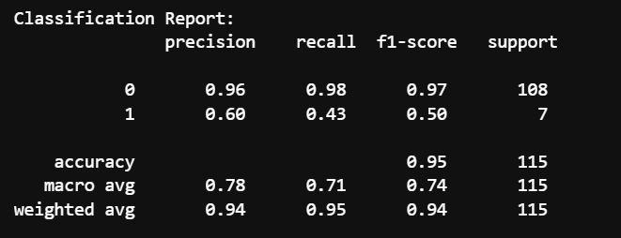

• **Accuracy**: 95%

• **Precision (Churn)**: 60%

• **Recall (Churn)**: 43%

• **F1 Score (Churn)**: 50%

**Confusion Matrix ::**

|  | **Predicted: Stay** | **Predicted: Churn** |
| --- | --- | --- |

|  |  |  |
| --- | --- | --- |
| **Actual: Stay** | 106 | 2 |

|  |  |  |
| --- | --- | --- |
| **Actual: Churn** | 4 | 3 |

* True Negative :106 (correctly predicted stay)
* False Positive : 2(predicted churn, but stayed)
* False Negatives: 4(predicted stay, but churned)
* True Positive: 3 (correctly predicted churn)

**Business Implications ::**

**🡪**Accurately identifying churners enables proactive retention strategies, such as offering discounts or improved services to high-risk customers.

**🡪**Reducing churn by even a small percentage can significantly increase customer lifetime value and long-term profitability.

🡪A predictive churn model allows for resource optimization by targeting at-risk customers more efficiently.

## Conclusion

The logistic regression model provides a strong starting point for churn detection, particularly in terms of overall accuracy. However, to effectively capture churners and reduce false negatives, further model tuning and advanced techniques are recommended. Improved churn prediction can support data-driven decision-making, helping business enhance customer retention and boost profitability.